Lab 1: Getting Started with C++

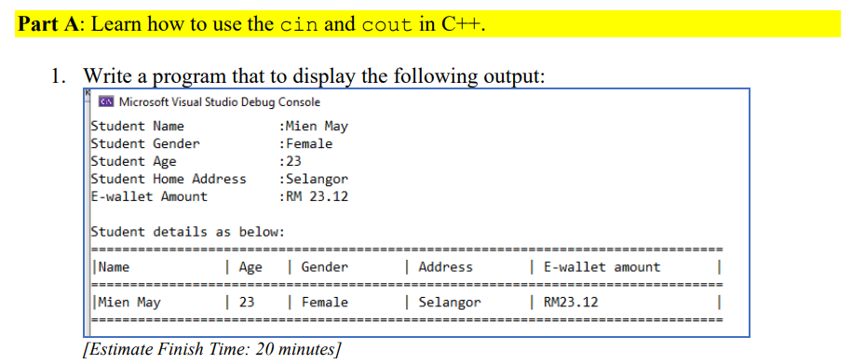

Code:

#include <iostream>

using namespace std;

int main()

{

    cout << "Student Name        : Mien May" << endl;

    cout << "Student Gender      : Female" << endl;

    cout << "Student Age         : 23" << endl;

    cout << "Student Home Address: Selangor" << endl;

    cout << "E-wallet Amount     : RM 23.12" << endl << endl;

    cout << "Student details as below:" << endl;

    cout << "=============================================================" << endl;

    cout << "| Name      | Age | Gender | Address   | E-wallet amount    |" << endl;

    cout << "=============================================================" << endl;

    cout << "| Mien May  | 23  | Female | Selangor  | RM23.12            |" << endl;

    cout << "=============================================================" << endl;

    return 0;

}

Output:  
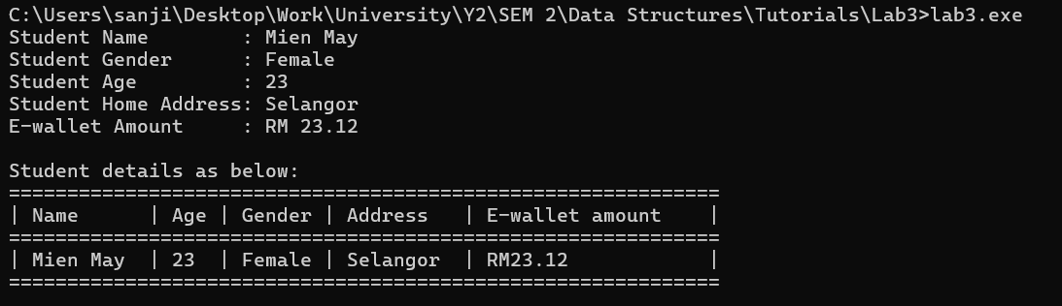

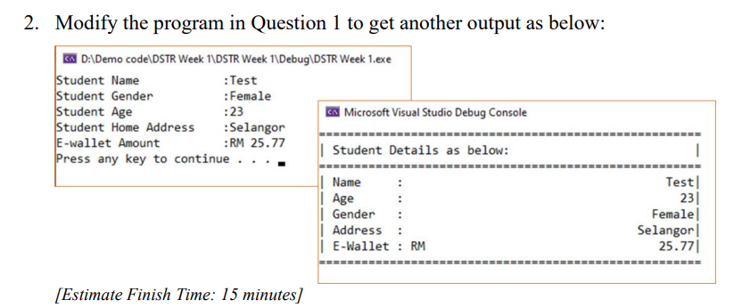

Code:

#include <iostream>

#include <string>

#include <iomanip>

using namespace std;

int main()

{

    string name, gender, address;

    int age;

    double ewalletAmount;

    cout << "Student Name        : ";

    getline(cin, name);

    cout << "Student Gender      : ";

    getline(cin, gender);

    cout << "Student Age         : ";

    cin >> age;

    cin.ignore();

    cout << "Student Home Address: ";

    getline(cin, address);

    cout << "E-Wallet Amount     : RM ";

    cin >> ewalletAmount;

    cin.ignore();

    cout << "Press Enter to continue . . .";

    cin.get();

    cout << "\nStudent Details as below:\n";

    cout << "====================================================" << endl;

    cout << "| Name   : " << name << endl;

    cout << "| Age    : " << age << endl;

    cout << "| Gender : " << gender << endl;

    cout << "| Address: " << address << endl;

    cout << "| E-Wallet: RM " << fixed << setprecision(2) << ewalletAmount << endl;

    cout << "====================================================" << endl;

    return 0;

}

Output:

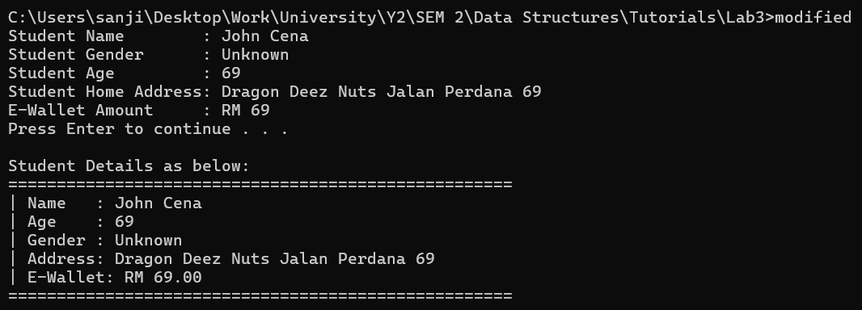

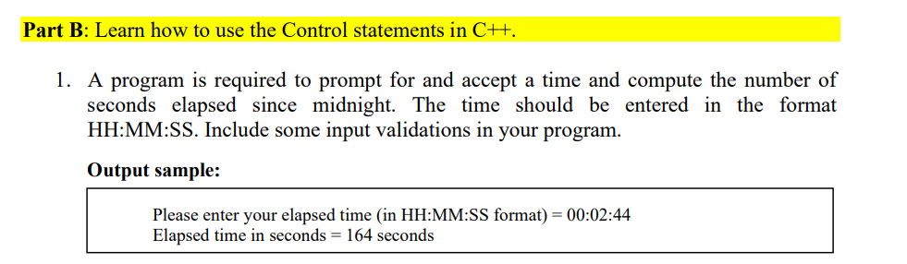

Code:

#include <iostream>

#include <string>

#include <sstream>  //

using namespace std;

bool isValidTime(int hh, int mm, int ss) {

    return (hh >= 0 && hh <24) && (mm >= 0 && mm < 60) && (ss >= 0 && ss < 60);

}

int main() {

    string input;

    int hh, mm, ss;

    char colon1, colon2;

    while (true) {

        cout << "Please enter your elapsed time (in HH:MM:SS format) = ";

        cin >> input;

        stringstream ssInput(input);

        if (ssInput >> hh >> colon1 >> mm >> colon2 >> ss

            && colon1 == ':'

            && colon2 == ':'

            && isValidTime(hh, mm, ss))

        {

            break;

        }

        cout << "Invalid input! Please enter a valid time in HH:MM:SS format.\n";

    }

    int totalSeconds = hh \* 3600 + mm \* 60 + ss;

    cout << "Elapsed time in seconds = " << totalSeconds << " seconds\n";

    return 0;

}

Output:



